CLOUD COMPUTING LAB: WEEK 2

PES1201802127

Siddharth K Rao

1. Task A: The Objective of this task is to setup up a web server on the AWS EC2 Instance and host a sample web page on the instance. You are also required to load test the web page by using Apache Bench and monitor the EC2 instance using AWS CloudWatch service.

1a) Creating EC2 Instance:

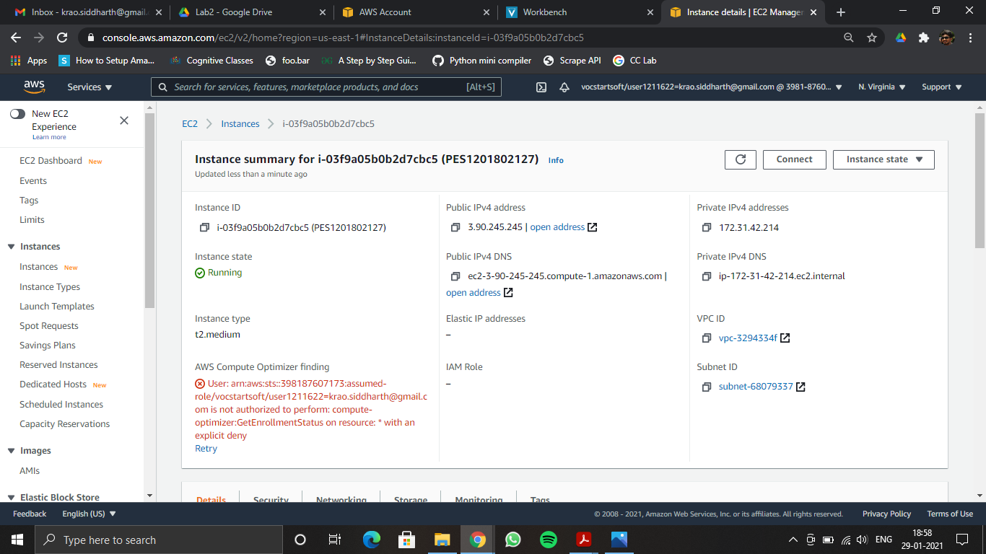

2a) Installing Apache web Server on AWS EC2 Instance:

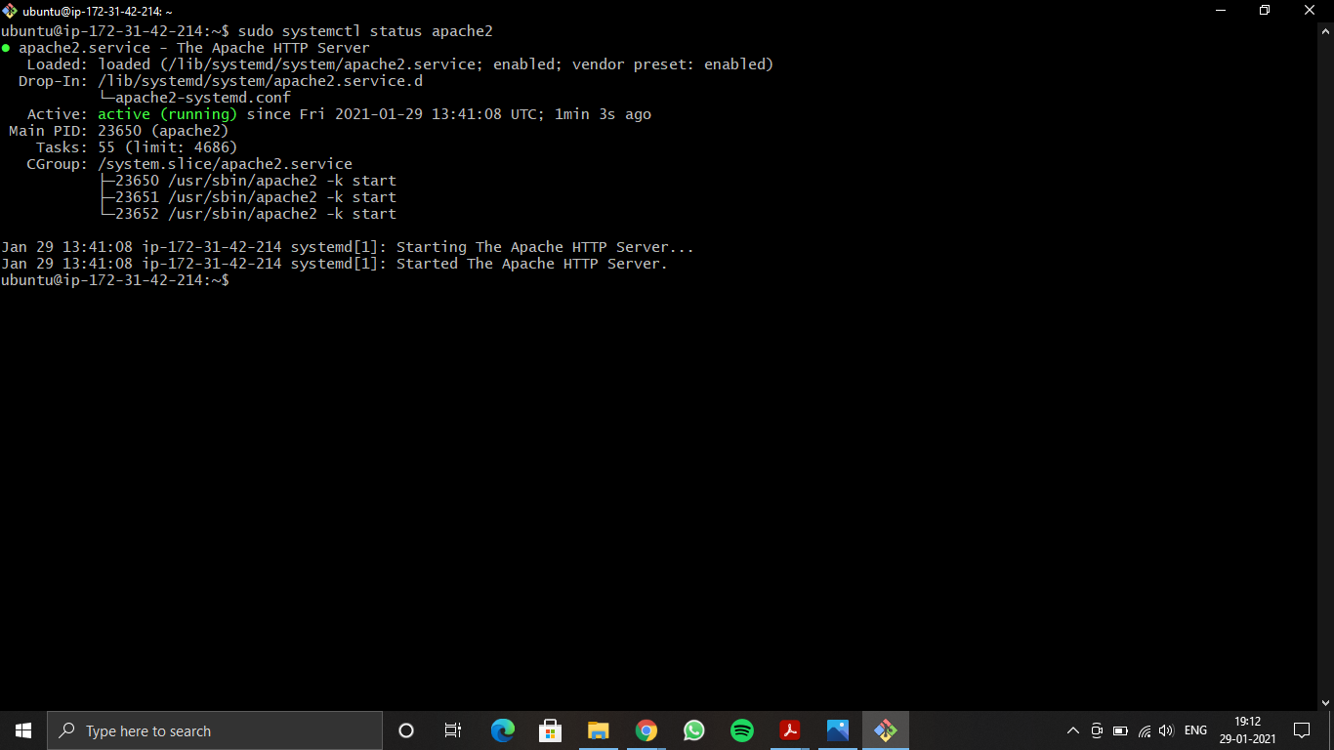

3a) Setting up Firewall rules and showing the list of rules updated:

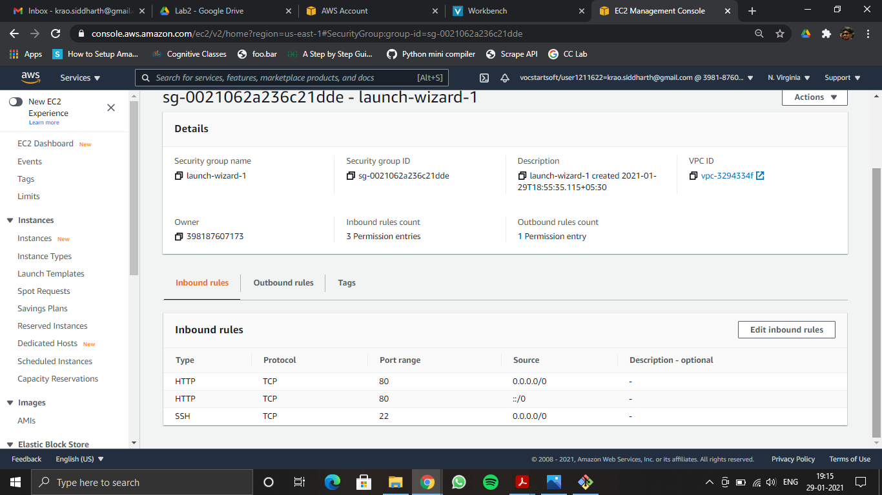

3b) Local browser showing EC2 Instance’s Apache2 Ubuntu Default Page:

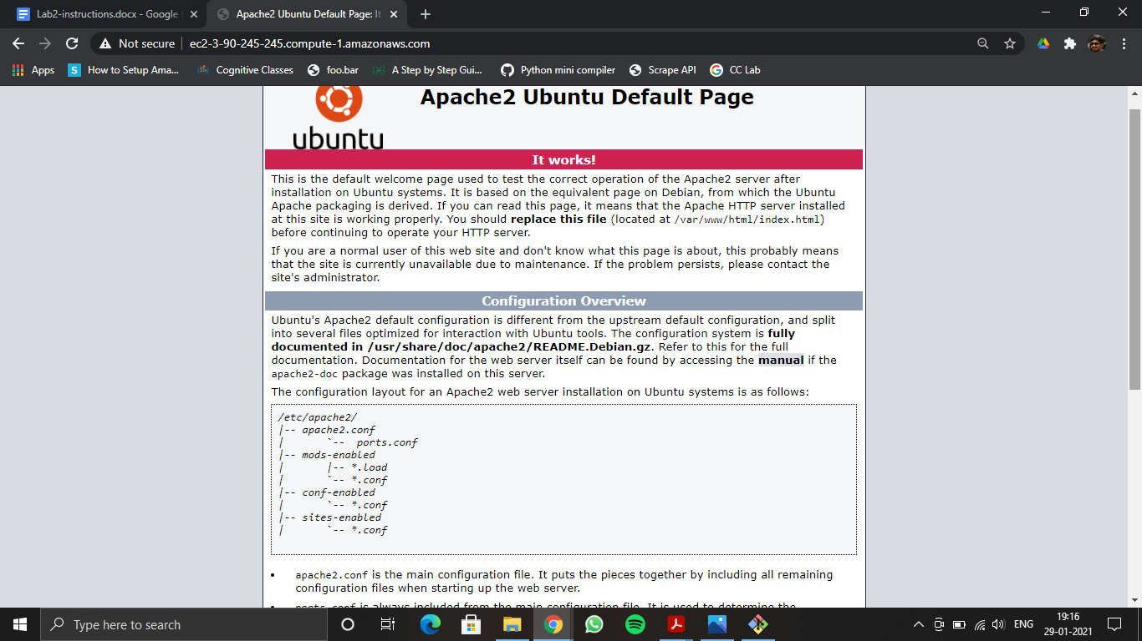

4a) Hosting a sample web page:

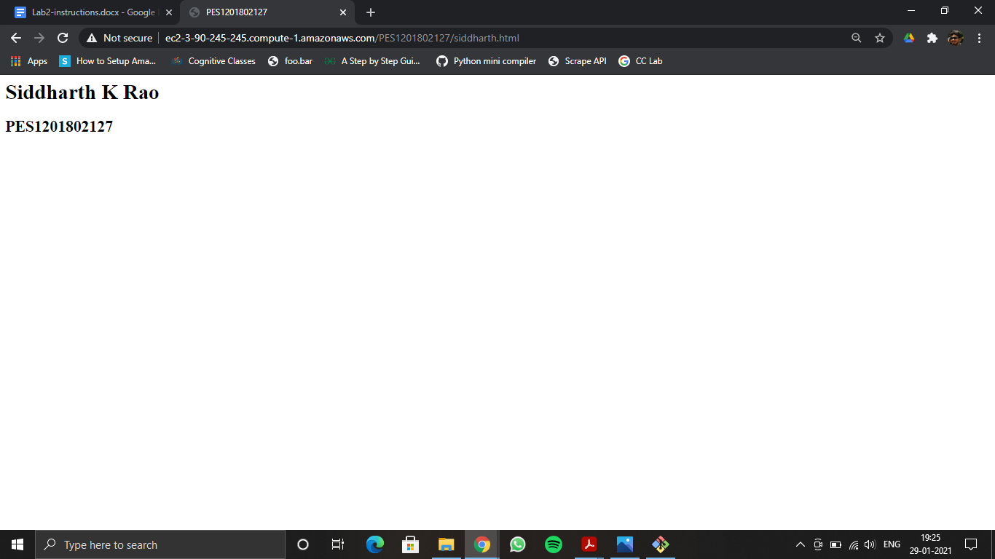

5a) Apachebench output report after execution:

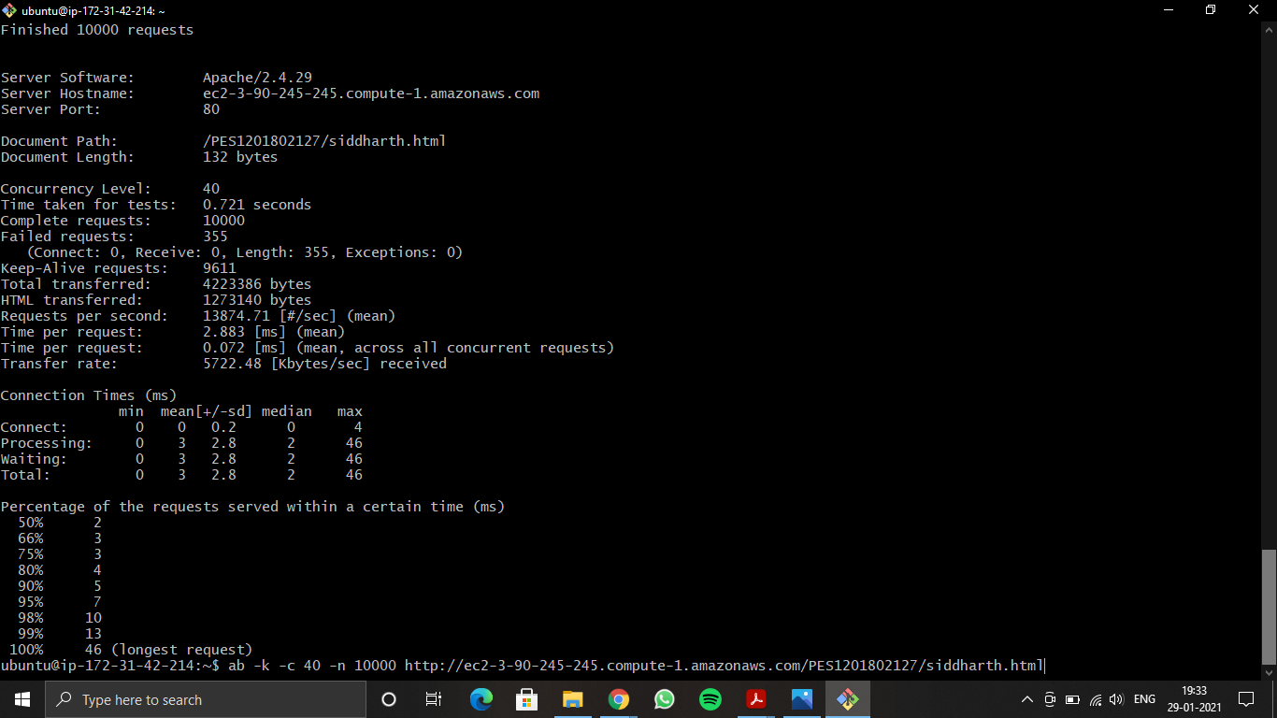

5b) All set of graphs:

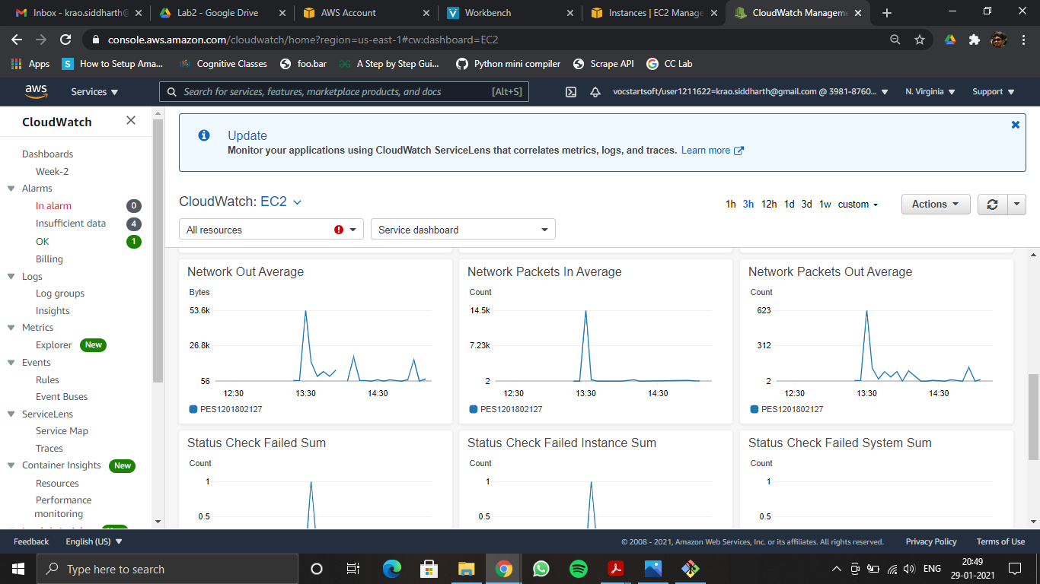

5c) CPU Utilization:

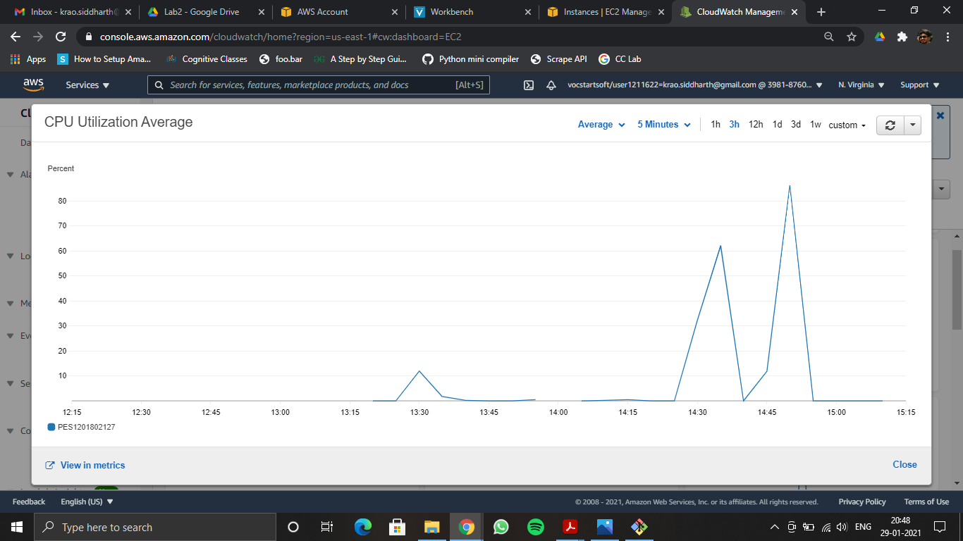

1. Task 2: Deploying Flask app On AWS Elastic Beanstalk

In this task you’ll be asked to create a AWS Elastic Beanstalk environment and deploy the flask application provided to you. You are required to configure a RDS along with your Beanstalk environment and create a few tables and databases.

B1) Environment Health:

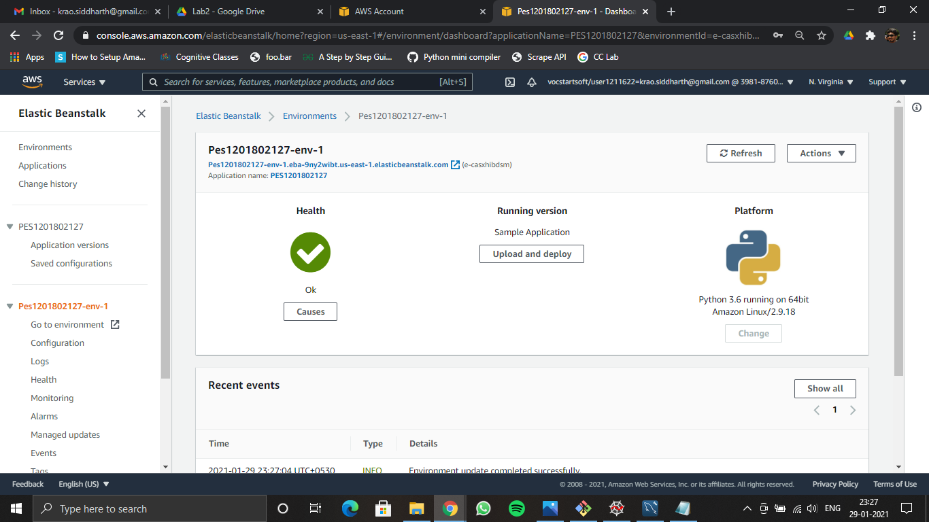

B2) DB Configuration:

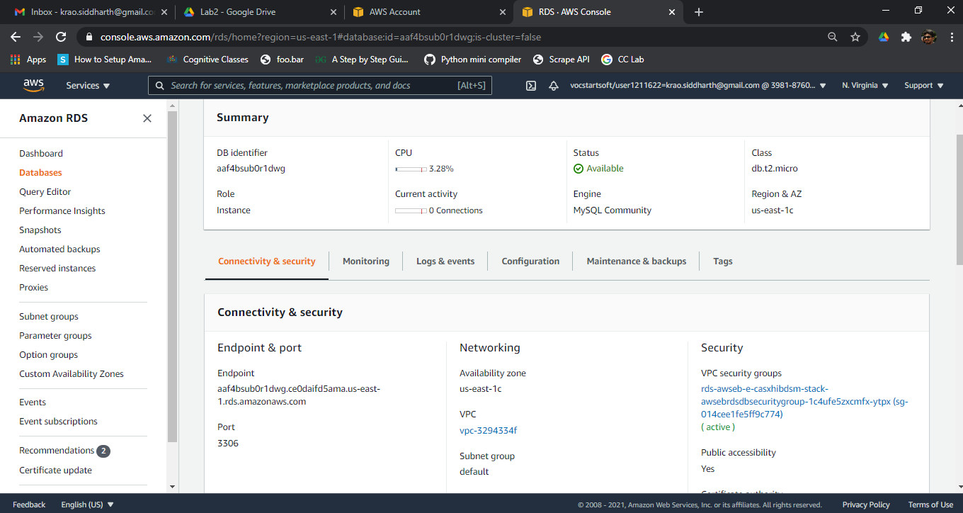

B3) Register User Request:

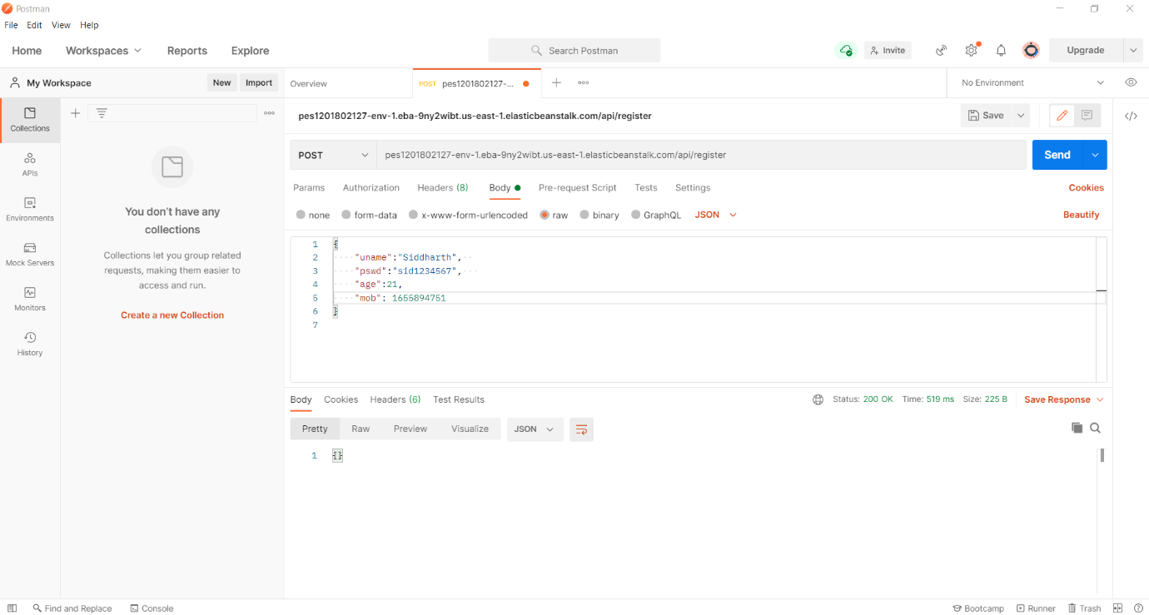

B4) Verify User Request:

